MATH 2253 PRACTICE TEST 1

FALL 2016

You must show all applicable work to get credit.

1. The table gives the position s(t) of an object moving along a line at time t, over a three-second interval. Find the average velocity over the following intervals:



Average velocity = over the interval [*a*, ***b***], or equivalently for 

(a) [0, 3]

. Answer: −3 ft /sec. Note that units are an important part of the answer.

(b) [0, 1.5]

. Answer: − ft /sec

2. A rock is dropped from the edge of a cliff to the water 256 feet below. Its distance from the top of the cliff after t seconds is s(t) = 16t2.

(a) When will the rock strike the water?



Since *t* cannot be negative . Answer: After 4 seconds

(b) Complete the table below and estimate the velocity at which the rock strikes the water. Round your answer to the nearest whole number.



The rock will the water at 128 ft/sec

3. Below is the graph of a function 

(a) Find 

Ans:  = 3

(b) Find 

You have to imagine approaching  along the curve from either side, as indicated by the red arrows, and then see if the function value approaches some value. It must be the same value from either side. You can see that the *y*-value approaches 0 from each side. So,

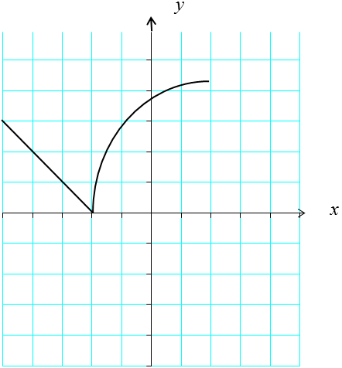

Ans: 

(c) Find all values *c* such that  fails to exist.

 fails to exist when the function values approach different values from the left and right. (or if the function does not approach a fixed value from one or both sides).

Note that  exists if the function is continuous at . Generally speaking  fails to exist if there is a jump in the graph at . The only place there is a jump in the graph is at .

Ans: When , because there is a jump in the graph at 2.

4.

. 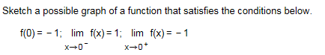

A possible graph is:

5.



A possible graph is:

a.

b.

6. Evaluate 

You can find limits of polynomials by substitution.

2(3) − 7 = −1

7. Suppose p and q are polynomial functions . If  and .

Since *p* and *q* are polynomials you can find their limits by substitution.



8. Find the unique constants b and c in the polynomial  such that .

Since the limit exists must be a factor of , making for some *k*.

Then 

Since you can find limits of polynomials by substitution 

Then 

So, 

9. Find 



10. Find where 

Since *x* is approaching 1 from the left you use the formula for that applies for values of *x* less than 1.



11. Refer to the following graph to find the limits:

(a)  (b)  (c) 

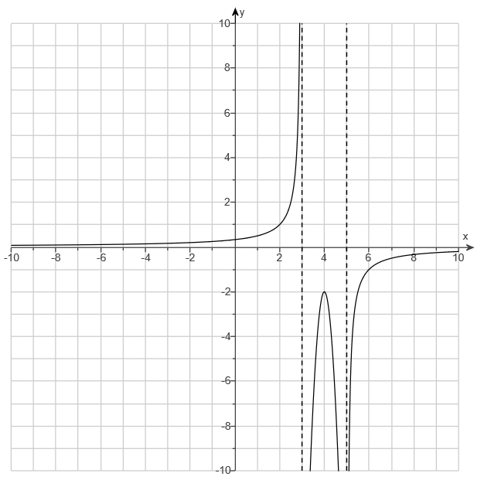

(a)  (b)  (c) 

12. Find 

Imagine *x* being a little bit bigger than 4, and then look at the sign of each factor: You have

, which is negative.

We know there is an asymptote at , so 

13. Find 

14. Find the vertical asymptotes of 

15. Find 

16. Find 

17. Find the oblique asymptote of 

18. Find the horizontal asymptote of 

19.

