CHEM1211 Chapter 8 Homework Spring 2015

1. The bond length in an HI molecule is 1.61 Å and the measured dipole moment is 0.44 D. What is the magnitude (in units of *e*) of the negative charge on I in HI?

(1 debye = 3.34 × 10-30 coulomb-meters; e=1.6 × 10-19 coulombs)

1. Given that the average bond energies for C-H and C-Br bonds are 413 and 276 kJ/mol, respectively. Calculate the heat of atomization of bromoform (CHBr3).
2. a. In the resonance form of ozone shown below, calculate the formal charge on the central oxygen atom.

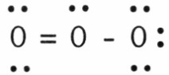

b. Formal charges on F and Cl in Cl-F

1. Draw all equivalent resonance forms for CO32-(carbon is the central atom).
2. Using the table of average bond energies below, calculate the ΔH for the reaction.

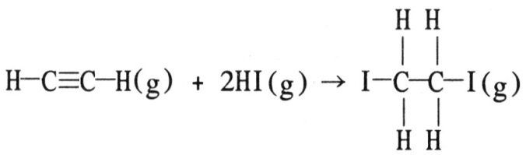

Bond: C≡C C–C H–I C–I C–H

D (kJ/mol): 839 348 299 240 413

1. Draw the Lewis structure for **(a)** NO+ ion, **(b)** C2H4.
2. Draw the best Lewis structure for SeO42-
3. Write electronic configuration for following ions:
4. P3-
5. Cr2+
6. Ba2+
7. I-