Chem 1211 Practice Questions Chapter 5
- Calculate the kinetic energy in J of an electron moving at 6.00 × 106 m/s. The mass of an electron is 9.11 × 10-28 g.

- The value of ΔE for a system that performs 111 kJ of work on its surroundings and gains 89 kJ of heat is __________ kJ.

- The value of ΔH° for the reaction below is -72 kJ. __________ kJ of heat are released when 79.9 grams of HBr is formed in this reaction.
H2 (g) + Br2 (g) → 2HBr (g)

- The value of ΔH° for the reaction below is -790 kJ. The enthalpy change accompanying the reaction of 0.95 g of S is __________ kJ.
2S (s) + 3O2 (g) → 2SO3 (g)

- The value of ΔH° for the reaction below is -336 kJ. Calculate the heat (kJ) released to the surroundings when 23.0 g of HCl is formed.

CH4 (g) + 3 Cl2 (g) → CHCl3 (l) + 3HCl (g)

- The value of ΔH° for the reaction below is -1107 kJ:

2Ba (s) + O2 (g) → 2BaO (s)
How many kJ of heat are released when 5.75 g of Ba (s) reacts completely with oxygen to form
BaO (s)?

- A sample of calcium carbonate [CaCO3 (s)] absorbs 45.5 J of heat, upon which the temperature of the sample increases from 21.1 °C to 28.5 °C. If the specific heat of calcium carbonate is 0.82 J/g-K, what is the mass (in grams) of the sample?

- An 8.29 g sample of calcium carbonate [CaCO3 (s)] absorbs 50.3 J of heat, upon which the temperature of the sample increases from 21.1 °C to 28.5 °C. What is the specific heat of calcium carbonate?
- The specific heat capacity of lead is 0.13 J/g-K. How much heat (in J) is required to raise the temperature of 15 g of lead from 22 °C to 37 °C?

- The temperature of a 35.2 g sample of iron increases from 23.7 °C to 29.5 °C. If the specific heat of iron is 0.450 J/g-K, how many joules of heat are absorbed?

- Consider the following two reactions:
A → 2B ΔH°rxn = 456.7 kJ
A → C ΔH°rxn = -22.1kJ
Determine the enthalpy change for the process:
2B → C
- ΔH for the reaction
IF5 (g) → IF3 (g) + F2 (g)
is __________ kJ, give the data below.
IF (g) + F2 (g) → IF3 (g) ΔH = -390 kJ
IF (g) + 2 F2 (g) → IF5 (g) ΔH = -745 kJ

- Given the following reactions
Fe2O3 (s) + 3CO (s) → 2Fe (s) + 3CO2 (g) ΔH = -28.0 kJ
3Fe (s) + 4CO2 (s) → 4CO (g) + Fe3O4 (s) ΔH = +12.5 kJ
the enthalpy of the reaction of Fe2O3 with CO
3 Fe2O3 (s) + CO (g) → CO2 (g) + 2 Fe3O4 (s)
is __________ kJ.
- The value of ΔH° for the reaction below is -186 kJ.
H2 (g) + Cl2 (g) → 2HCl (g)
The value of ΔHf° for HCl (g) is __________ kJ/mol.

- Given the following reactions:
2S (s) + 3O2 (g) → 2SO3 (g) ΔH = -790 kJ
S (s) + O2 (g) → SO2 (g) ΔH = -297 kJ
the enthalpy of the reaction in which sulfur dioxide is oxidized to sulfur trioxide
2SO2 (g) + O2 (g) → 2SO3 (g)
is __________ kJ.

- Given the data in the table below, ΔH°rxn for the reaction
Ca(OH)2 + 2 H3AsO4 → Ca(H2AsO4)2 + 2 H2O
is __________ kJ.

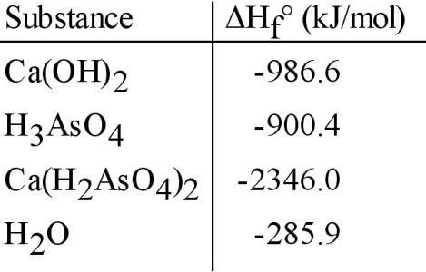
- Given the data in the table below, ΔH°rxn for the reaction
C2H5OH (l) + O2 (g) → CH3CO2H (l) + H2O (l)
is __________ kJ.

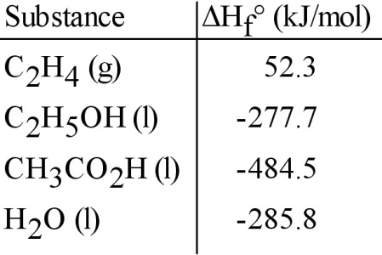
- A 5-ounce cup of raspberry yogurt contains 6.0 g of protein, 2.0 g of fat, and 20.2 g of carbohydrate. The fuel values for protein, fat, and carbohydrate are 17, 38, and 17 kJ/g, respectively. The fuel value of this cup of yogurt is __________ kJ.
- The ΔH for the solution process when solid sodium hydroxide dissolves in water is 44.4 kJ/mol. When a 10.1-g sample of NaOH dissolves in 250.0 g of water in a coffee-cup calorimeter, the temperature increases from 23.0 °C to __________°C. Assume that the solution has the same specific heat as liquid water, i.e., 4.18 J/g-K.

- The combustion of titanium with oxygen produces titanium dioxide:
Ti (s) + O2 (g) → TiO2 (s)
When 2.060 g of titanium is combusted in a bomb calorimeter, the temperature of the calorimeter increases from 25.00 °C to 91.60 °C. In a separate experiment, the heat capacity of the calorimeter is measured to be 9.84 kJ/K. The heat of reaction for the combustion of a mole of Ti in this calorimeter is __________ kJ/mol.

